PRDA – 04 Customer Data Analysis

Submitted by: Yekabote Nanditha

Table of Contents

PRDA – 04 Customer Data Analysis 1
Project Introduction 2
Dataset Description 3
Dataset Attribute Table 4
Dataset Setup and Connection 4
Power BI Analysis 5
Introduction 5
Dataset Description 5
Tools used in power bi 5
Data preparation in power bi 6
Task 1: Shopping Distribution According to Gender 6
Task 2: Which gender we sell more products to 7
Task 3: Which gender generated more revenue 8
Task 4: Distribution pf purchase categories related to other columns 9
Task 5&6: Shopping distribution and products sold by age category 10
Task 7: Which age category generated more revenue 12
Task 8: Distribution of purchase category related to age 13
Task 9: Does the payment method have a relation with other columns 14
Task 10: How is the distribution of the payment method 15
Conclusion 16
PRDA-04: Customer Data Analysis Dashboard 17

Project Introduction
This project focuses on analyzing customer shopping behavior using transactional data collected from different shopping malls. The analysis helps to understand customer demographics, purchasing patterns, payment methods, and revenue generation.
SQL is used to extract, analyze, and calculate important information from the dataset. Power BI is used to visualize the analyzed data through an interactive dashboard. The insights obtained from the analysis can help businesses understand customer preferences, improve marketing strategies, and make better business decisions.

Dataset Description
The dataset contains customer shopping transaction data collected from multiple shopping malls. It includes information about customer demographics, product categories, quantity purchased, product price, payment methods, transaction dates, and shopping mall locations.
The main columns in the dataset include Invoice Number, Customer ID, Gender, Age, Category, Quantity, Price, Payment Method, Invoice Date, and shopping mall.

Dataset Attributes Table

COLUMN NAME | DESCRIPTION
Invoice_no | Unique invoice number
Customer_id | Unique customer ID
Gender | Gender of the customer
Age | Age of the customer
Category | Product Category
Quantity | Number of items purchased
Price | Price per unit
Payment_Method | Payment method used
Invoice_date | Date of transaction
Shopping_mall | Shopping mall name

DATABASE SETUP & CONNECTION
The dataset was accessed from a MYSQL database using MYSQL workbench. A successful connection to the remote database was established, and the required database and customer table were verified for analysis.
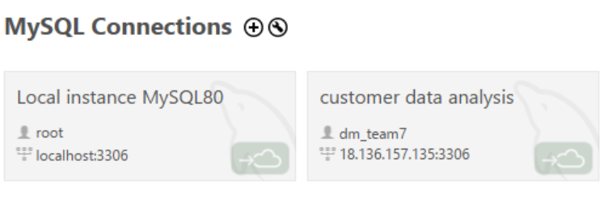
Power BI Analysis
Introduction
In this project, Power BI is used to analyze customer shopping data . The purpose of using Power BI is create visual reports and understand customer behavior easily through charts and graphs.
Dataset Description
The dataset contains customer shopping details such as
- Invoice number
- Customer Id
- Gender
- Age
- Product Category
- Quantity
- Price
- Payment Method
This data helps us to explain shopping patterns of customers.
Tools Used in Power BI
- Microsoft Power BI Desktop (visualizations)
- Microsoft Excel (Dataset)
Data Preparation in Power BI
Before creating the chart, the following steps are done.
- Opened Power BI Desktop
- Click on Get data.
- Selected Excel Workbook.
- Choose the downloaded dataset file.
- Clicked load to import the data.
- Checked all the columns were loaded correctly.
- Verified there was no missing values in gender column.
Task 1: Shopping Distribution According to Gender
Objective:
To analyze the distribution of shopping transactions based on customer gender.
Analysis:
The shopping transactions were analyzed by grouping customers based on gender and counting the number of transactions for each gender.

Insight:
Female customers account for approximately 60% of the total shopping transactions, while male customers account for approximately 40%. This indicates that female customers have a higher share of shopping transactions in the dataset.
Conclusion:
The company can focus on female customers through targeted marketing campaigns, offers, and loyalty programs to further increase customer engagement and sales.
Visualization:
A Donut Chart was created in Power BI to show the shopping distribution by gender.
Chart title: Shopping Distribution by Gender

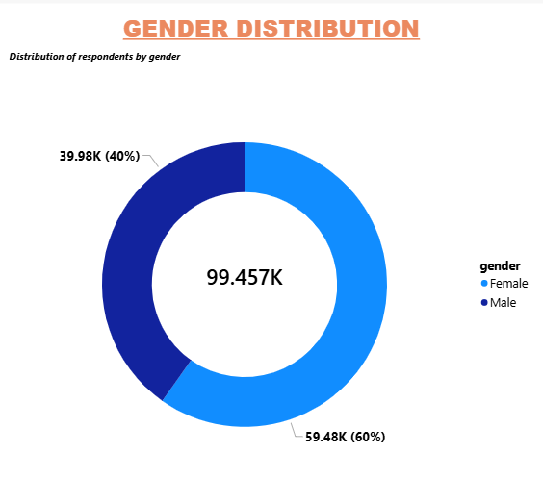

Task 2: Which Gender Did We Sell More Products To?
Objective:
To identify which gender purchased the highest quantity of products.
Analysis:
The total quantity of products sold was compared between male and female customers using Power BI.
Insight:
Female customers purchased more products than male customers. This indicates that female customers contributed a larger share of the total products sold.
Conclusion:
The company can focus on female customers by offering targeted promotions, discounts, and product recommendations to increase sales further.
Visualization:
A Clustered Column Chart was used to compare the total products sold to male and female customers.
Chart Title: Products Sold by Gender
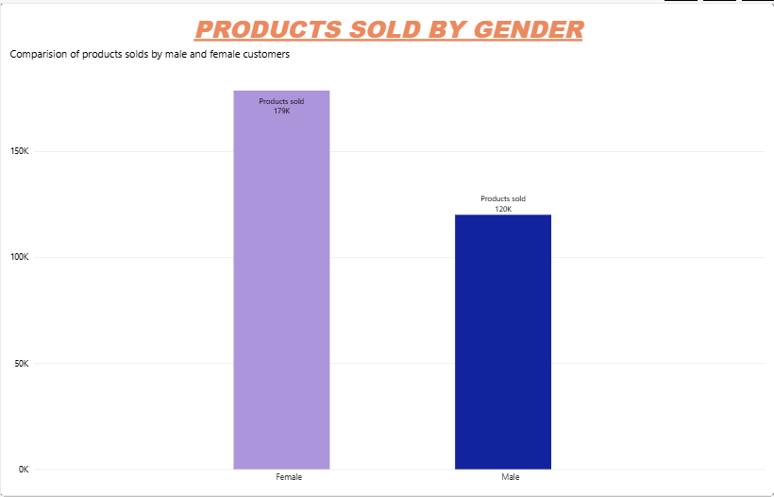
Task 3: Which Gender Generated More Revenue?
Objective:
To identify which gender contributed more revenue to the business.
Analysis:
The total revenue was calculated by multiplying the quantity purchased by the product price and then comparing the revenue generated by male and female customers.
Insight:
Female customers generated more revenue than male customers. This indicates that female customers contributed a larger share of the total revenue.
Conclusion:
The company can focus on female customers with targeted offers, personalized promotions, and loyalty programs to further increase revenue.
Visualization:
A Clustered Column Chart was used to compare total revenue generated by male and female customers.
Chart Title: Revenue Generated by Gender
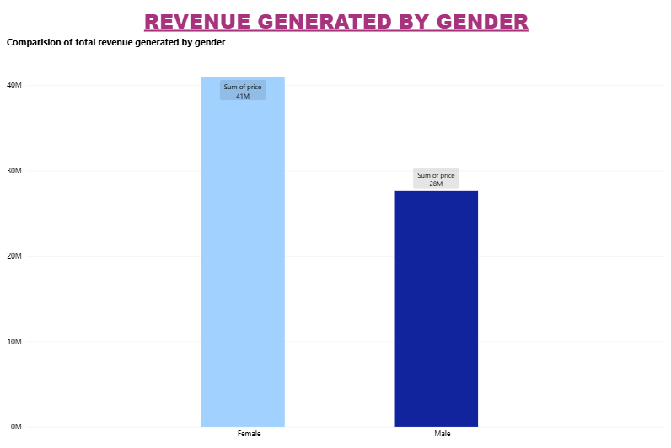

Task 4: Distribution of Purchase Categories Relative to Other Columns
Objective:
To analyze the distribution of different product categories purchased by customers.
Analysis:
The number of transactions was compared across different product categories and genders to understand customer purchasing patterns.
Insight:
The analysis shows that Clothing has the highest number of purchases, followed by Cosmetics and Food & Beverage. Other categories such as Shoes, Toys, Technology, and Souvenir have comparatively fewer transactions.
Conclusion:
The company should maintain sufficient inventory for high-demand categories such as Clothing and Cosmetics, while using targeted promotions to increase sales in lower-performing categories.
Visualization:
A Stacked Column Chart was used to compare purchase categories by gender.
Chart Title: Purchase Category Distribution by Gender
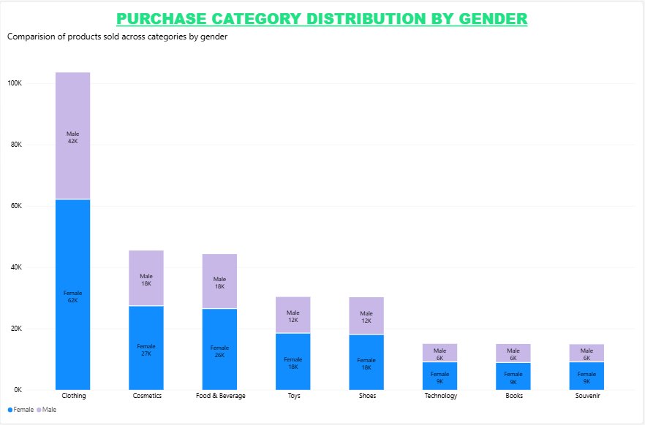

Tasks 5 & 6: Shopping Distribution and Products Sold by Age Category
Objective:
To analyze shopping activity across different age categories and identify which age category purchased the highest quantity of products.
Analysis:
Customers were grouped into different age categories — 18–25, 26–35, 36–45, 46–55, and 56+. The number of shopping transactions and total products sold were compared for each age category.
Insights:
The 26–35 age group shows a high level of shopping activity.
The 26–35 age group purchased the highest quantity of products compared with the other age groups.
This indicates that customers in the 26–35 age category are an important customer segment for the business.

Conclusion:
The company can focus on the 26–35 age group through targeted offers, personalized promotions, and suitable product recommendations to increase customer engagement and sales.
Visualizations:
Shopping Distribution by Age Group – Column Chart
Products Sold by Age Group – Bar/Column Chart
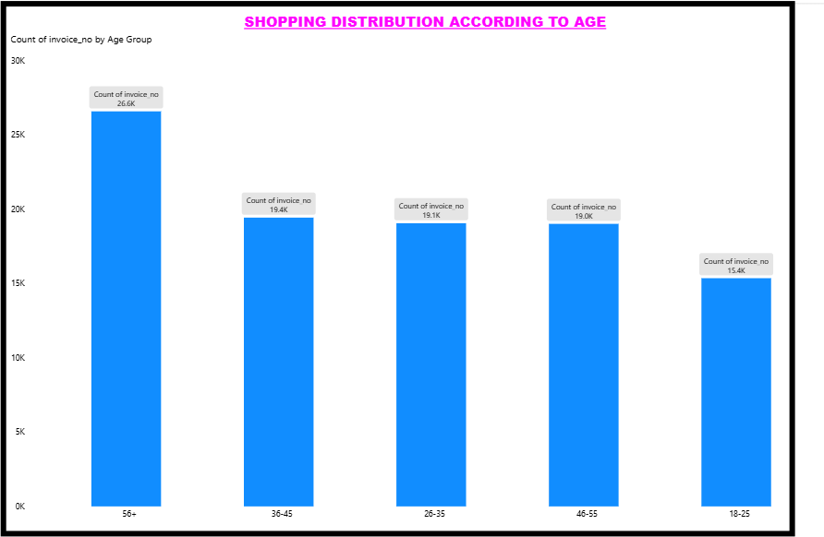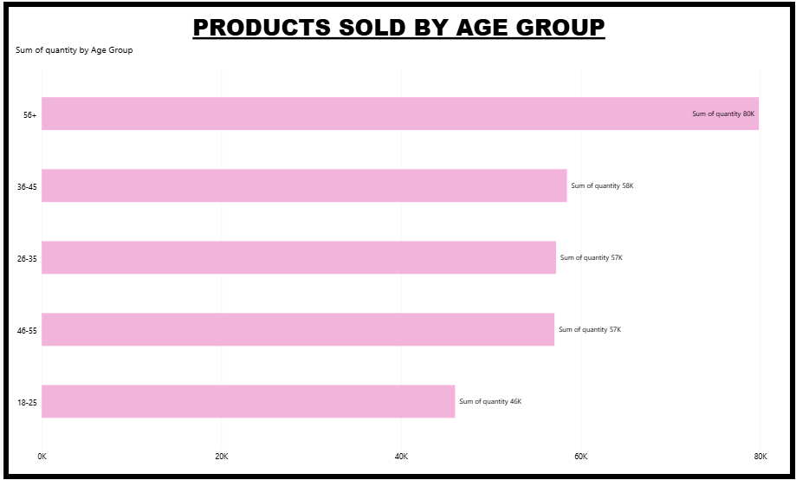

Task 7: Which Age Category Generated More Revenue?
Objective:
To identify which age category contributed the highest revenue to the business.
Analysis:
The total revenue was calculated using the quantity purchased × product price and compared across different age categories.

Insight:
The 26–35 age group generated the highest revenue compared with the other age categories. This indicates that customers in this age group are an important revenue-generating segment for the business.
Conclusion:
The company can focus on the 26–35 age group by providing targeted offers, personalized recommendations, and loyalty programs to increase revenue further.
Visualization:
A Column Chart was used to compare revenue generated by different age categories.
Chart Title: Revenue Generated by Age Group
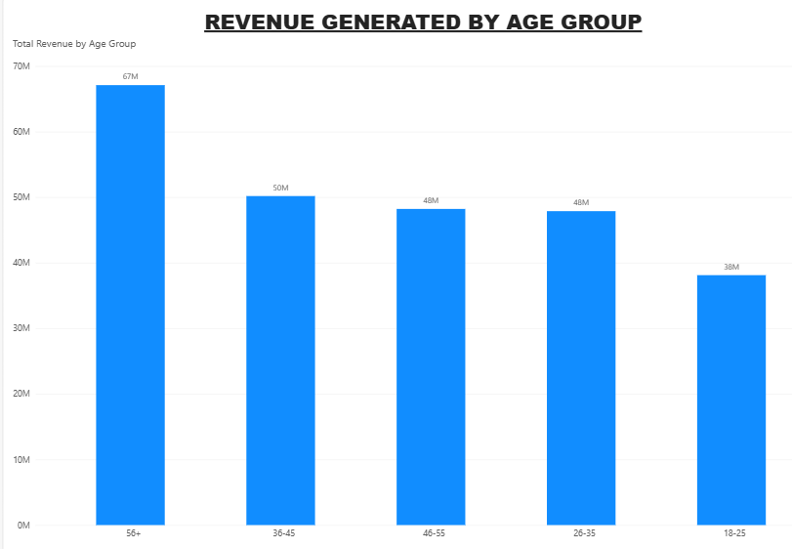
Task 8: Distribution of Purchase Categories Relative to Age
Objective:
To analyze the distribution of different product categories purchased across different age groups.

Analysis:
Customers were grouped into different age categories, and their purchases were compared across various product categories to understand the purchasing preferences of each age group.
Insight:
The analysis shows that purchase preferences vary across different age groups. Some product categories have higher demand among particular age groups, while other categories have comparatively lower demand.
Conclusion:
The company can use these age-wise category preferences to create targeted marketing campaigns, personalized product recommendations, and age-specific offers. This can help improve customer engagement and increase sales.
Visualization:
A Stacked Column Chart was used to show the distribution of purchase categories across different age groups.
Chart Title: Purchase Category Distribution by Age Group
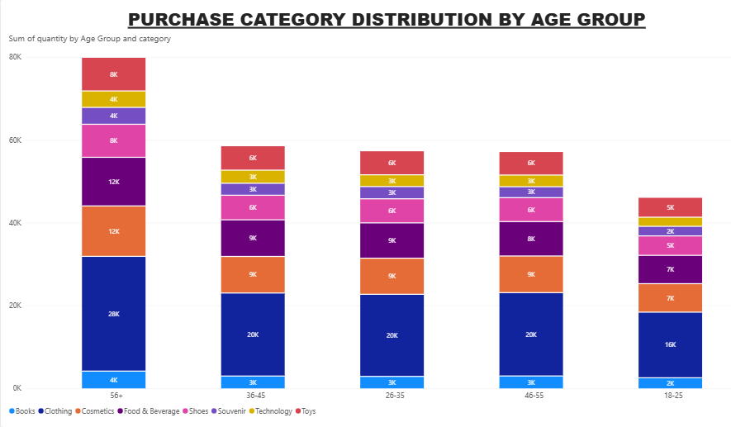

Task 9: Does the Payment Method Have a Relation with Other Columns?
Objective:
To analyze whether the payment method used by customers is related to other customer and transaction attributes.
Analysis:
The relationship between payment method and other columns such as gender, product category, and age group was analysed to understand customers' payment preferences.
Insight:
The analysis shows that customers use different payment methods across genders, age groups, and product categories. Credit Card,cash and Debit Card are the main payment methods used by customers. The distribution varies across different customer segments.
Conclusion:
Understanding payment preferences can help the company provide suitable payment options, targeted offers, and a better shopping experience for different customer segments.
Visualization:
A Stacked Column Chart was used to analyse the relationship between payment method and gender.
Chart Title: Payment Method by Gender
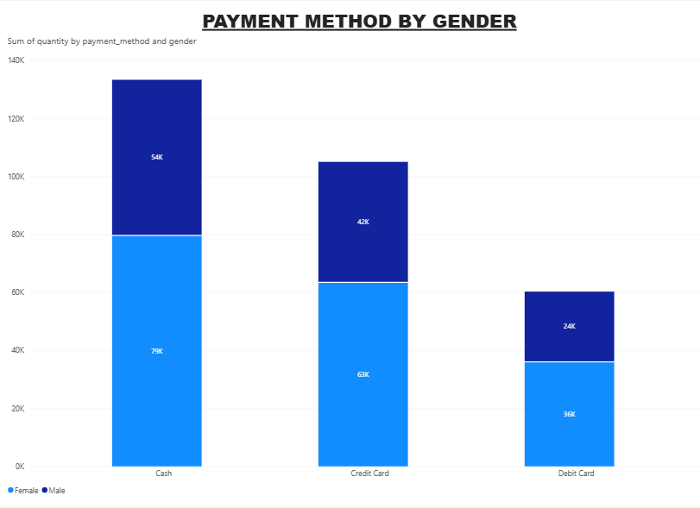

Task 10: How Is the Distribution of the Payment Method?
Objective:
To analyze the distribution of different payment methods used by customers for their purchases.
Analysis:
The number of transactions was compared across the three payment methods: Cash, Credit Card, and Debit Card.
Insight:
The analysis shows that customers use all three payment methods for their transactions. Credit Card is the most commonly used payment method, followed by Cash and Debit Card.
Conclusion:
The company should continue supporting all major payment methods and can provide payment-specific offers or incentives to encourage customers to make more purchases.

Visualization:
A Donut Chart was used to display the distribution of payment methods.
Chart Title: Payment Method Distribution
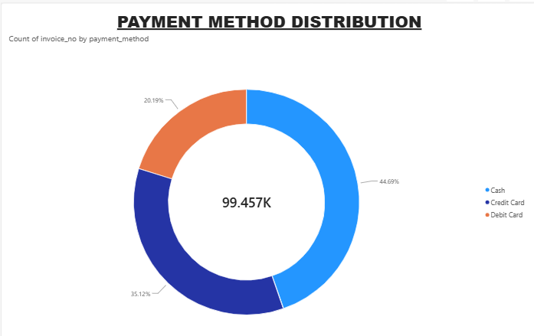

Conclusion:
The Power BI dashboard successfully visualizes customer revenue using different perspectives. Revenue by Gender shows the contribution of male and female customers. Revenue by Groups helps identify which age groups generate more sales. Sales by Payment method highlights most preferred payment options. Overall, the dashboard provides clear insights can help business understand customer behavior and make better decisions.

PRDA-05 CUSTOMER DATA ANALYSIS DASHBOARD
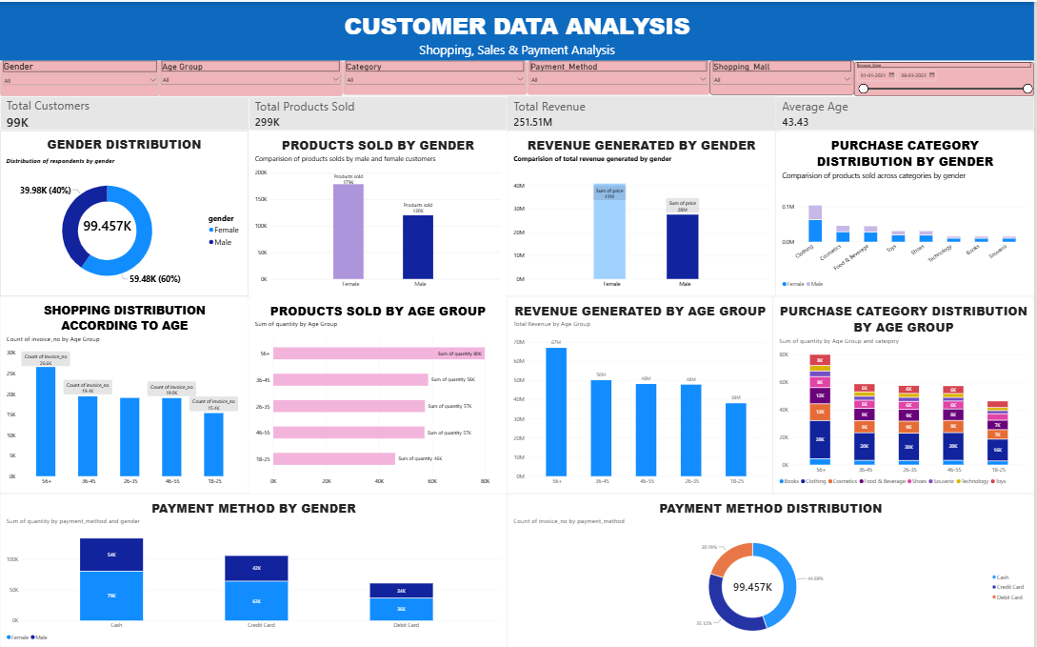

Key Business Insights:
Female customers contribute a larger share of transactions, product purchases, and revenue. The 56+ age group shows strong purchasing behavior and revenue contribution. Clothing is the most popular product category, while payment preferences vary across customer segments.
Business Recommendations:
The company should focus on targeted marketing for high-value customer segments, maintain sufficient inventory for high-demand categories, provide age- and gender-specific offers, personalize product recommendations, and support multiple payment methods.

